1. Goal of the website:

The website will provide a number of API sourced, as well as calculated, metrics on a property (projected rent, Cap Rate etc.) that allow a user to more easily figure out how good a property might be as an investment. Users will be able to save properties to their accounts and edit their saved properties, and even make hypothetical properties.

1. User demographic:

Anyone looking to invest in properties (probably more first-time buyers, but also experienced buyers.)

1. Data I plan on using:

Zillow or similar API, to get general info on property (Zestimate®, walk score, sqft, lot size, Mortgage estimate, rent estimate etc.)

1. In brief, outline your approach to creating your project (knowing that you may not know everything in advance and that these details might change later).
2. What kinds of issues might you run into with your API?

No property matching address, multiple matches for an address, missing data for certain fields on certain addresses entered.

1. Is there any sensitive information you need to secure?

Login Passwords

1. What functionality will your app include?

Account creation, Login/Logout, edit account, searching for a property by address, entering property info manually, modifying property data (like rent & expenses), show various calculated investment property metrics for a property (like cap rate) that change when property data is changed, ability for a user to save properties to their account.

1. What features make your site more than CRUD? Do you have any stretch goals?

Add the ability to compare saved properties.

1. What will the user flow look like?

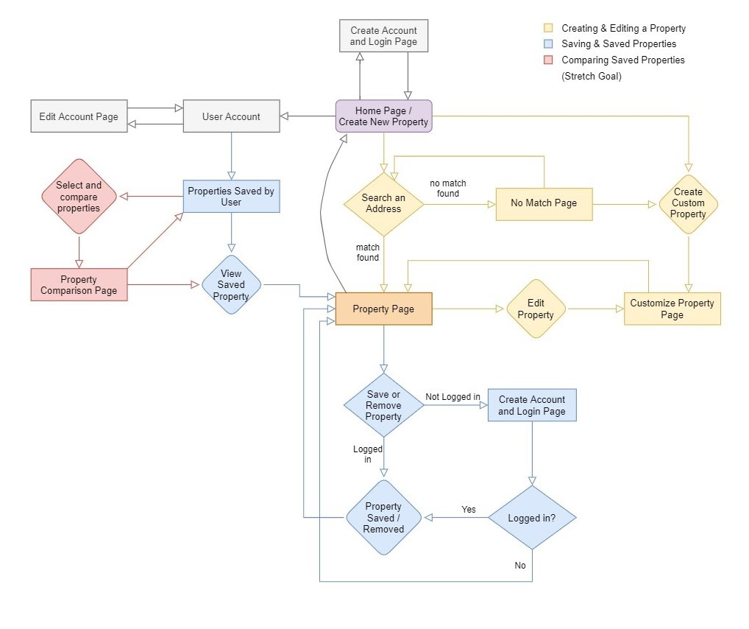

1. What does your database schema look like?

Basic Idea, will need updating.

